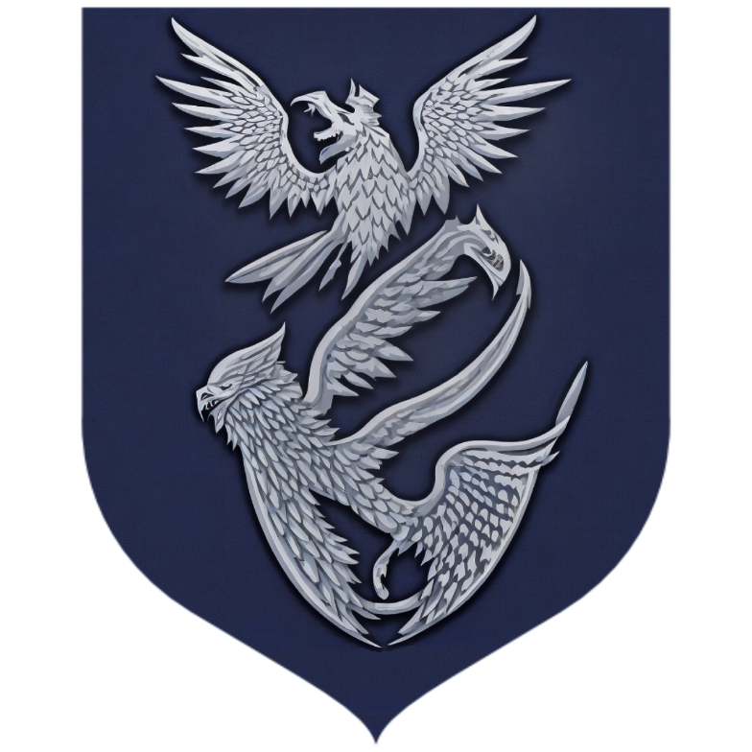

House Jangard

*“Vigilance in Shadows, Wisdom in Whispers.”*

Legend has it that the founder of House Jangard, Ser Eamon Jangard, was a renowned warrior who emerged victorious in a legendary battle against an army of White Walkers during the Long Night. Recognized for his courage and strategic brilliance, Ser Eamon earned the favor of the Starks of Winterfell, who granted him lands and titles, establishing House Jangard as loyal bannermen to House Stark.

Over the centuries, the Jangards earned a reputation as formidable warriors, fiercely devoted to the defense of the North. They defended the realm against numerous threats, including Wildling incursions and Ironborn raids. The ancestral seat of House Jangard, known as Frostspire Keep, stands atop a snow-covered mountain, overlooking vast valleys and treacherous passes.

Despite their martial prowess, the Jangards also cultivated a tradition of wisdom and knowledge. Many members of the house were renowned scholars, maesters, and advisors to the lords of Winterfell. They amassed an extensive library within Frostspire Keep, safeguarding ancient tomes and arcane knowledge.

The Jangard sigil proudly displays two silver falcons soaring against a midnight blue background representing their keen vision, swift actions, and unwavering focus. The falcon symbolizes their ability to perceive opportunities amidst chaos and their determination to seize them without hesitation. A keen eye will also notice a hidden serpent in the Jangard sigil, symbolizing their commitment to knowledge, and veiled obscurity.

As their house words, spoken only in the hushed tones of the Frostspire Keep, the Jangards adopted the motto 'Vigilance in Shadows, Wisdom in Whispers.' This encapsulates their commitment to observing the intricate web of power and making calculated moves in the shadows, never revealing their true intentions until the opportune moment.